Strategic Market and Trend Analysis
  - Apparel, Textiles and Fashion Industry

Submitted by: Divya Sri S
Role: Junior Machine Learning Data Analyst
Project: Week 1 – Strategic Market and Trend Analysis
Dataset: Apparel Sales Dataset
Tools: Python, Pandas, Matplotlib, Scikit-learn

1.Introduction

The apparel, textile, and fashion industry is influenced by changing consumer preferences, seasonal demand, product performance, regional markets, and store-level sales patterns. Data analysis can help businesses understand historical sales behaviour and identify trends that may support future decision-making.

This project focuses on analysing an apparel sales dataset using Python-based data analysis and forecasting techniques. The analysis examines sales performance across different regions, stores, products, years, and months. Key performance indicators such as total sales, total units sold, and average sales per record are also calculated.

The project further explores historical sales trends and applies forecasting approaches to estimate future sales. Different forecasting methods are evaluated using performance metrics such as MAE, RMSE, and R². The findings are used to develop strategic recommendations that can help businesses improve inventory planning, identify high-performing products and stores, and make data-driven decisions.

2.Dataset Description

The dataset used in this project contains historical sales records from an apparel retail business. The dataset consists of 1,490 records and 7 columns. It contains information related to products, orders, units sold, sales amount, sale date, store, and region.
The main variables used for the analysis are Productid, OrderId, UnitsSold, Sales, SaleDate, Store, and Region. Productid identifies the product, while OrderId identifies the order. UnitsSold represents the quantity sold and Sales represents the sales value. SaleDate provides the date of each sales transaction. Store and Region provide information about the location associated with each transaction.
During data preparation, the SaleDate column was converted into datetime format for time-based analysis. No missing values were found in the original seven columns. However, while preparing the monthly time-series data, March 2021 was identified as a missing month. Linear interpolation was used to estimate this value so that the monthly series could be used continuously for forecasting.

Column | Description | Data Type
Productid | Product identifier | Integer
OrderId | Order identifier | Integer
UnitsSold | Number of units sold | Integer
Sales | Sales amount | Integer
SaleDate | Date of sale | DateTime
Store | Store identifier | Text
Region | Store region | Text

3.Data Preparation and Cleaning

Data preparation was performed before conducting the analysis to ensure that the dataset was suitable for further processing. The dataset was examined for its structure, data types, and missing values. The dataset contains 1,490 records and 7 columns. The initial inspection showed that the SaleDate column was stored as an object data type, so it was converted into datetime format to enable date-based analysis.

A missing-value check was also performed across all columns. No missing values were found in the original dataset. During the preparation of monthly sales data for forecasting, March 2021 was found to have no recorded monthly value. Linear interpolation was applied to estimate the missing monthly value between February and April 2021. This allowed the time-series dataset to maintain a continuous monthly sequence for forecasting analysis.

3.1 Data Quality Check

The dataset was checked for missing values and data-type consistency. All seven original columns contained 1,490 non-null records. The numerical columns were identified as integer data types, while Store and Region were categorical text fields. SaleDate was converted to datetime format for time-series analysis.

4. Exploratory Data Analysis (EDA)

4.1 Key Performance Indicators (KPIs)
Key Performance Indicators (KPIs) were calculated to obtain an overall understanding of the sales performance in the dataset. The analysis showed that the total sales generated across all records were 668,119,032, while the total number of units sold was 19,029. The average sales value per record was approximately 448,402. These KPIs provide a basic overview of the overall sales performance before analysing individual regions, stores, products, and time periods.
KPI | Value
Total Sales | 668,119,032
Total Units Sold | 19,029
Average Sales per Record | 448,402
4.2 Regional Sales Analysis
Regional sales analysis was performed to understand the contribution of each region to the overall sales performance. The analysis showed that the West (W) region generated the highest sales of 176,275,560, followed by the North (N) region with 171,678,918. The East (E) region generated 165,064,930, while the South (S) region recorded the lowest sales of 155,099,624. The results indicate that sales performance varies across regions, with the West region being the strongest contributor to overall sales
Region | Total Sales
W | 176,275,560
N | 171,678,918
E | 165,064,930
S | 155,099,624
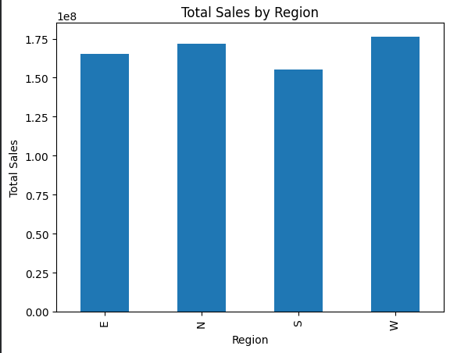

4.3 Store Sales Analysis
Store-level sales analysis was performed to identify the contribution of individual stores to overall sales performance. The analysis showed that Store2 recorded the highest sales of 176,275,560, followed by Store3 with 98,496,441 and Store4 with 96,124,741. Store6 recorded the lowest sales of 65,982,795. The results indicate that Store2 is the strongest-performing store in terms of total sales.
Store | Total Sales
Store2 | 176,275,560
Store3 | 98,496,441
Store4 | 96,124,741
Store5 | 89,116,829
Store1 | 73,182,477
Store7 | 68,940,189
Store6 | 65,982,795

4.4 Product Sales Analysis
Product-level sales analysis was performed to identify the products that generated the highest sales. The analysis showed that Product 128 recorded the highest total sales of 25,905,418, followed by Product 142 with 25,516,700 and Product 127 with 24,028,787. Product 134 and Product 143 also showed strong sales performance, with total sales of 23,674,405 and 21,926,274, respectively. These results help identify the products that contribute significantly to overall sales and can support product-level inventory and sales planning.
Product ID |  |  | Total Sales |  |  |  | Total Units
128 |  |  | 25,905,418 |  |  |  | 292
142 |  |  | 25,516,700 |  |  |  | 355
127 |  |  | 24,028,787 |  |  |  | 327
134 |  |  | 23,674,405 |  |  |  | 270
143 |  |  | 21,926,274 |  |  |  | 225
131 |  |  | 20,726,210 |  |  |  | 230
139 |  |  | 20,698,886 |  |  |  | 233
140 |  |  | 18,819,020 |  |  |  | 235
158 |  |  | 18,278,491 |  |  |  | 421
146 |  |  | 17,323,780 |  |  |  | 490
4.5 Time-Based Sales Analysis
Time-based sales analysis was performed to understand how sales changed across different years and months. The analysis covered the period from February 2021 to April 2024. Annual sales increased substantially over the period, with 2023 recording the highest total sales of 314,621,329. Sales in 2021 were 15,557,750, while sales increased to 128,887,296 in 2022 and 209,052,657 in 2024 up to April.
At the monthly level, sales showed considerable variation throughout the analysis period. The highest monthly sales were recorded in April 2024, with sales of 61,752,780, while the lowest monthly sales were recorded in July 2021, with sales of 129,956. The monthly analysis indicates an overall increase in sales toward the later part of the dataset, particularly during late 2023 and early 2024.

Year |  |  |  |  | Total Sales
2021 |  |  |  |  | 15,557,750
2022 |  |  |  |  | 128,887,296
2023 |  |  |  |  | 314,621,329
2024* |  |  |  |  | 209,052,657
2024 values are available only up to April.

Metric |  |  |  |  |  | Month |  |  |  |  |  | Sales
Highest Monthly Sales |  |  |  |  |  | April 2024 |  |  |  |  |  | 61,752,780
Lowest Monthly Sales |  |  |  |  |  | July 2021 |  |  |  |  |  | 129,956

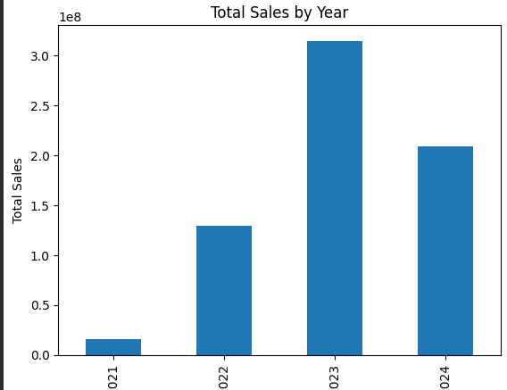

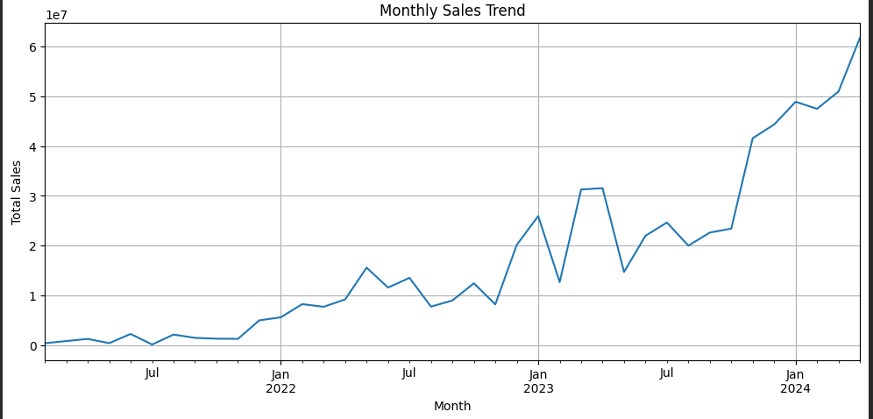

4.6 Moving Average Analysis
A three-month moving average was used to smooth short-term fluctuations in monthly sales and identify the underlying sales trend. The moving average was calculated using the sales values from the current month and the two preceding months. The analysis showed that the moving average increased considerably toward the later months of the dataset. By April 2024, the three-month moving average reached approximately 53,391,640, indicating a strong upward trend in recent sales performance.
Based on the latest three-month moving average, the estimated sales for the next month were approximately 53,391,637. This provides a simple baseline forecast and can be useful for short-term planning and inventory management.

Month |  |  |  |  | 3-MonthMoving Average
2023-11 |  |  |  |  | 29,200,760
2023-12 |  |  |  |  | 36,436,110
2024-01 |  |  |  |  | 44,925,010
2024-02 |  |  |  |  | 46,889,730
2024-03 |  |  |  |  | 49,099,960
2024-04 |  |  |  |  | 53,391,640

5. Forecasting Analysis

Sales forecasting was performed to estimate future sales based on historical monthly sales data. The available monthly sales data was divided into training and testing datasets. The training data consisted of observations from February 2021 to October 2023, while the testing data consisted of observations from November 2023 to April 2024.
Different forecasting approaches were explored, including Linear Regression, Log Linear Regression, Holt-Winters Exponential Smoothing, and Moving Average forecasting. The models were evaluated using Mean Absolute Error (MAE), Root Mean Squared Error (RMSE), and R² Score to understand their forecasting performance.
5.1 Training and Testing Data
Dataset |  |  |  |  | Period |  |  |  |  | Number of Months
Training |  |  |  |  | Feb 2021 – Oct 2023 |  |  |  |  | 33
Testing |  |  |  |  | Nov 2023 – Apr 2024 |  |  |  |  | 6
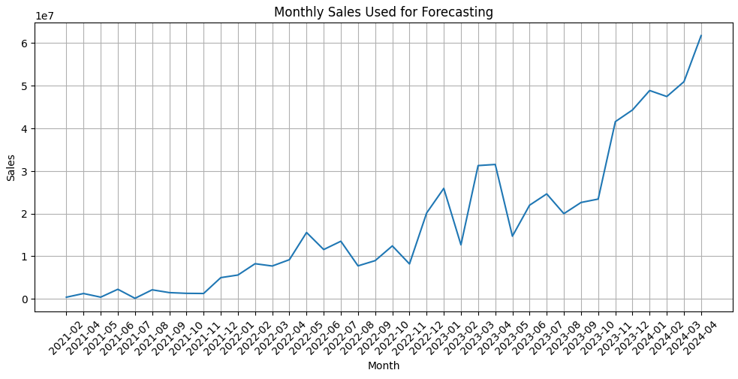

5.2 Linear Regression Forecasting
Linear Regression was initially applied to model the relationship between the time index and monthly sales. The time index was used as the independent variable, while monthly sales was treated as the dependent variable. The model estimated future sales by learning the overall linear trend from the training data.

Month |  |  |  |  |  |  |  |  |  | Forecasted Sales
Nov 2023 |  |  |  |  |  |  |  |  |  | 26,190,978
Dec 2023 |  |  |  |  |  |  |  |  |  | 27,064,971
Jan 2024 |  |  |  |  |  |  |  |  |  | 27,938,965
Feb 2024 |  |  |  |  |  |  |  |  |  | 28,812,958
Mar 2024 |  |  |  |  |  |  |  |  |  | 29,686,952
Apr 2024 |  |  |  |  |  |  |  |  |  | 30,560,945

The Linear Regression model produced an increasing forecast over the six-month testing period. However, the predicted values were considerably lower than the actual sales observed during the testing period. This resulted in a MAE of 20,782,363.86, RMSE of 21,393,630.65, and R² score of -10.18. The negative R² indicates that the model did not capture the actual sales pattern effectively.
5.3 Holt-Winters Forecasting
Holt-Winters Exponential Smoothing was applied to the monthly sales data to capture trend and potential seasonal patterns. Unlike Linear Regression, this method gives greater importance to recent observations and is therefore useful for time-series forecasting. The model was trained using the historical training data and used to forecast the six-month testing period from November 2023 to April 2024.
Month |  |  |  |  | Forecasted Sales
Nov 2023 |  |  |  |  | 25,405,820
Dec 2023 |  |  |  |  | 26,176,720
Jan 2024 |  |  |  |  | 26,947,620
Feb 2024 |  |  |  |  | 27,718,520
Mar 2024 |  |  |  |  | 28,489,420
Apr 2024 |  |  |  |  | 29,260,320

The Holt-Winters model produced a gradually increasing forecast during the testing period. However, the predicted values remained significantly below the actual sales values, particularly during the later months. The model achieved a MAE of 21,825,254.64, RMSE of 22,442,790.23, and R² score of -11.30. The negative R² indicates that the model did not perform well in predicting the sharp increase in recent sales.
5.4 Log Linear Regression
Log Linear Regression was explored to model the relationship between time and sales after applying a logarithmic transformation to the sales values. The transformation was used to reduce the effect of large variations in the sales data and to represent the growth pattern in a different scale. The model was trained on the transformed sales values and the predictions were converted back to the original sales scale for evaluation.
Metric |  |  |  |  |  | Value
MAE |  |  |  |  |  | 29,783,595.90
RMSE |  |  |  |  |  | 32,058,788.91
R² Score |  |  |  |  |  | -24.10
The Log Linear Regression model did not perform well on the testing data. It produced a MAE of 29,783,595.90, an RMSE of 32,058,788.91, and an R² score of -24.10. The negative R² indicates that the model was unable to explain the variation in the recent sales data effectively. Therefore, this model was not selected as the final forecasting approach.
5.5 Model Comparison
The forecasting models were compared using Mean Absolute Error (MAE), Root Mean Squared Error (RMSE), and R² Score. These metrics were calculated using the testing data from November 2023 to April 2024. Lower MAE and RMSE values indicate smaller prediction errors, while an R² value closer to 1 indicates better explanatory performance.
The comparison showed that all three regression and exponential smoothing models produced negative R² scores. This indicates that these models were not able to capture the sharp increase in sales observed during the testing period. Among the three models, Linear Regression performed relatively better based on the R² score, while Log Linear Regression showed the weakest performance.
Model |  |  |  | MAE |  |  |  | RMSE |  |  |  | R² Score
Linear Regression |  |  |  | 20,782,363.86 |  |  |  | 21,393,630.65 |  |  |  | -10.18
Holt-Winters |  |  |  | 21,825,254.64 |  |  |  | 22,442,790.23 |  |  |  | -11.30
Log Linear Regression |  |  |  | 29,783,595.90 |  |  |  | 32,058,788.91 |  |  |  | -24.10
Interpretation
The negative R² values indicate that the tested models performed worse than a simple baseline based on the mean of the observed sales values. The main reason for the poor performance is the substantial increase in sales during the later part of the dataset, particularly from November 2023 to April 2024. The models based mainly on historical trend were unable to respond sufficiently to this rapid growth.
Therefore, the forecasting results should be interpreted as a limitation of the tested models rather than as an error in the dataset. The analysis demonstrates the importance of selecting forecasting methods that can better capture changing trends and seasonal behaviour in rapidly growing sales data.
5.6 Moving Average Baseline Forecast
A three-month moving average was used as a simple baseline method for short-term sales forecasting. The method uses the most recent three months of observed sales to estimate the following month's sales. Based on the available data up to April 2024, the three-month moving average was approximately 53,391,637. Therefore, the estimated sales for the next month were 53,391,637.
This forecast provides a simple and interpretable baseline for short-term planning. However, since the sales data shows a strong upward trend and considerable variation, the moving average forecast should be treated as an approximate estimate rather than an exact prediction.
Forecast Method |  |  | Forecast Period | Forecasted Sales
3-Month Moving Average |  |  | May 2024 | 53,391,637
6. Strategic Recommendations
Based on the sales analysis and forecasting results, several strategic recommendations can be proposed to improve sales performance and support better business decision-making. The analysis identified differences in performance across regions, stores, products, and time periods. These findings can be used to improve resource allocation, inventory planning, and sales strategies.
6.1 Regional and Store-Level Strategy
The West region recorded the highest regional sales, while Store2 was the highest-performing store. Management should analyse the factors contributing to their strong performance and consider applying successful practices to lower-performing regions and stores. Additional attention can be given to the South region and lower-performing stores to identify opportunities for improvement.
6.2 Product Strategy
Products with high total sales should be prioritised for inventory availability to reduce the risk of stock shortages. Sales-per-unit analysis can also help identify products that generate higher value per unit sold. This information can support product prioritisation and inventory planning.
6.3 Forecast-Based Planning
The sales trend showed strong growth during the later part of the dataset. Therefore, future planning should consider the increasing sales trend rather than relying only on historical averages. The three-month moving average forecast of 53,391,637 can be used as a short-term baseline for inventory and sales planning.
6.4 Data-Driven Decision Making
Regular monitoring of sales by region, store, product, and month can help management identify changes in performance early. Dashboard-based reporting can further support faster decision-making by presenting important KPIs and trends in an easily understandable format.

7. Conclusion
This project provided a comprehensive analysis of historical sales data to identify important patterns and trends in sales performance. The analysis examined sales across regions, stores, products, years, and months. The results showed that the West region and Store2 were the strongest contributors to sales, while 2023 recorded the highest annual sales. Product-level analysis also identified the top-performing products based on total sales.
Time-series analysis showed a significant increase in sales toward the later part of the dataset, with April 2024 recording the highest monthly sales of 61,752,780. Several forecasting techniques were explored, including Linear Regression, Holt-Winters, and Log Linear Regression. The negative R² scores indicated that these models were unable to effectively capture the rapid increase in recent sales.
A three-month moving average was therefore used as a simple baseline for short-term forecasting, resulting in an estimated next-month sales value of 53,391,637. Overall, the project demonstrates how data analysis and forecasting techniques can support sales monitoring, planning, inventory management, and data-driven business decisions.
8. References
- Python Software Foundation. Python Documentation.
- Pandas Documentation. Data Analysis and Manipulation.
- Matplotlib Documentation. Visualization with Python.
- Scikit-learn Documentation. Machine Learning Algorithms and Model Evaluation.
- Statsmodels Documentation. Time Series Analysis and Forecasting.
6.Google Colab. Cloud-based Python Development Environment.

